Dee Romito, Author of Books for Young Readers

AUTHOR PHOTOS

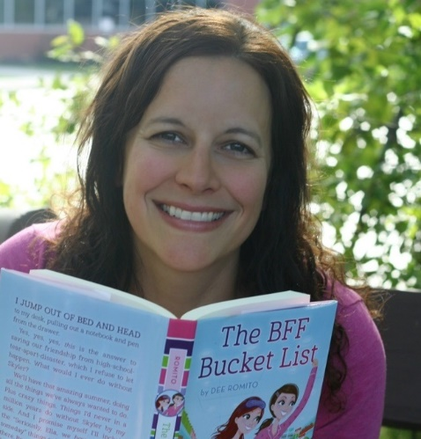
No photo credit needed

AUTHOR BIOS

Dee Romito is an author of books for young readers and a former elementary school teacher. Her middle grade books include The BFF Bucket List, No Place Like Home, Postcards from Venice, and co-authored Best.Night.Ever (Aladdin/S&S). Her debut picture book, Pies from Nowhere: How Georgia Gilmore Sustained the Montgomery Bus Boycott (Little Bee Books) received a starred review from Booklist and a Crystal Kite Award. Next up is a chapter book series titled Fort Builders (Aladdin/S&S), which will release in 2020. Dee blogs about writing at WriteforApples.com and is Co-Founder of Buffalo-Niagara Children’s Writers and Illustrators. While she does her best to be a grown-up most of the time, giggling with her BFFs is still one of her all-time favorite things. You can visit her website at deeromito.com.

Less than 100 words:

Dee Romito is an author of books for young readers. Her middle grade books include The BFF Bucket List, No Place Like Home, Postcards from Venice, and co-authored Best.Night.Ever. (Aladdin/S&S). Her debut picture book, Pies from Nowhere: How Georgia Gilmore Sustained the Montgomery Bus Boycott (Little Bee Books) received a starred review from Booklist and a Crystal Kite Award. Next up is her chapter book series, Fort Builders, Inc. (Aladdin/S&S, 2020). Dee loves to write, travel, and giggle like a teenager with her friends. You can visit her website at deeromito.com.​
Dee Romito is a former elementary teacher and an author of books for young readers from picture books to middle grade. She lives in her hometown of Buffalo, New York. And while she loves to travel and find new adventures, she’d certainly agree with Dorothy that there’s no place like home. You can visit her website at deeromito.com.

LINKS & SOCIAL MEDIA
Website http://www.deeromito.com/
Blog http://www.writeforapples.com/
Twitter https://twitter.com/writeforapples (@writeforapples)
Facebook https://www.facebook.com/DeeRomito.author (@writeforapples)
Instagram https://www.instagram.com/writeforapples/ (@writeforapples)
Goodreads https://www.goodreads.com/author/show/8557376.Dee_Romito

BOOKS

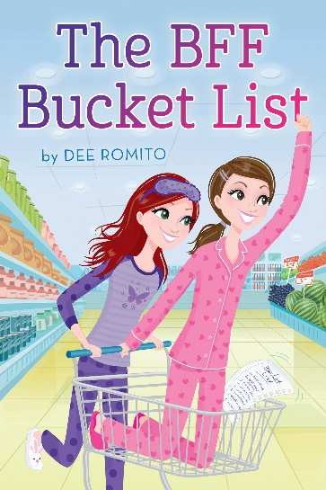
THE BFF BUCKET LIST
​Aladdin/Simon & Schuster
ISBN: 978-1481446426 (paperback)
ISBN: 978-1481446433 (hardcover)
Ella and Skyler have been best friends since kindergarten. Although lately, things have been different. Ella’s determined to fix things with a fun project she’s sure will bring them closer together—The BFF Bucket List. But as new friends, epic opportunities, and super-cute boys enter the picture, the challenges on the list aren’t the only ones they face.
Illustrations ©Annabelle Metayer
Ordering info: https://www.deeromito.com/thebffbucketlist.html
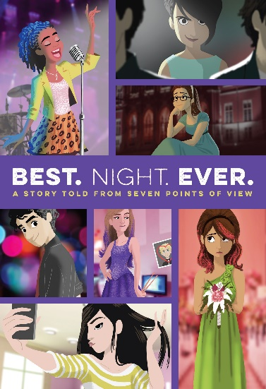
BEST. NIGHT. EVER.
​Aladdin/Simon & Schuster
ISBN: 978-1481486606 (hardcover)
ISBN: 978-1481486613 (paperback)
A middle grade novel in the format of Love, Actually, Seven Sides to Every Story is told from the perspective of seven different, but intersecting, characters. It takes place over the course of one night and is centered around a middle school dance.
Illustrations ©James Lopez
Ordering info: https://www.deeromito.com/best-night-ever.html
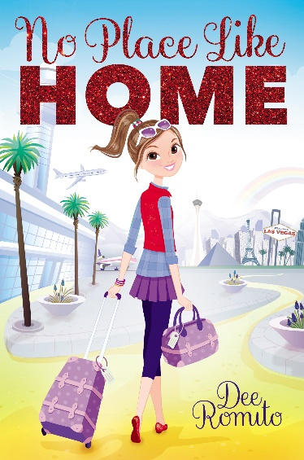
​NO PLACE LIKE HOME
Aladdin/Simon & Schuster
ISBN: 978-1481491082 (paperback)
ISBN: 978-1481491099 (hardcover)
A 12 year-old girl, used to flying around the country for her father's job, gets a chance to go to middle school for six weeks and sets out to see what she can accomplish without her VIP status.
Illustrations ©Annabelle Metayer
Ordering info: https://www.deeromito.com/no-place-like-home.html

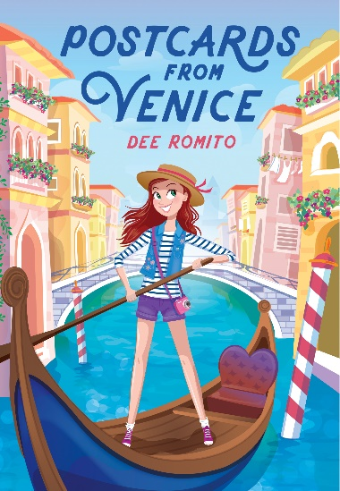
POSTCARDS FROM VENICE
Aladdin/Simon & Schuster
ISBN: 978-1534403376 (paperback)
ISBN: 978-1534403383 (hardcover)
Skyler is about to go on the biggest adventure of her life, blogging her way through summer in Venice, Italy, With the help of some Italian magic and her oldest friend, can Skyler learn to love her new city and stay connected to what matters most?
Illustrations ©Annabelle Metayer
Ordering info: https://www.deeromito.com/postcards-from-venice.html

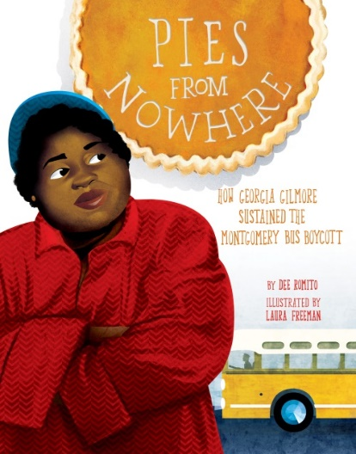
Pies from Nowhere: How Georgia Gilmore Sustained the Montgomery Bus Boycott
Little Bee Books
​ISBN: 978-1499807202
​This stunning picture book looks into the life of Georgia Gilmore, a hidden figure of history who played a critical role in the Civil Rights movement and used her passion for baking to help the Montgomery Bus Boycott achieve its goal.
Illustrations ©Laura Freeman
Ordering info: https://www.deeromito.com/pies-from-nowhere.html

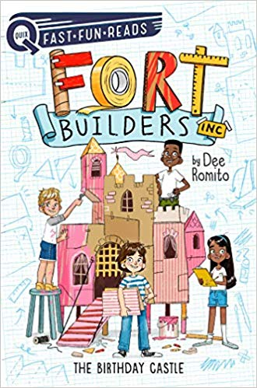
The Birthday Castle (Fort Builders #1)
Aladdin/Simon & Schuster
Releases May 19, 2020
978-1534452381 (paperback)
978-1534452398 (hardcover)

​A group of friends use teamwork, creativity, and construction know-how to start their own fort building company in the first story in a new, fun-to-read Aladdin QUIX chapter book series that’s perfect for emerging readers!
Illustrations ©Marta Kissi
Ordering Info: https://www.deeromito.com/fort-builders.html

